**Assignment 1 - Data Analysis** CA675 - Cloud Technologies

Name: Likitha Shivananjegowda

Student-Id: 22265298

Email : [likitha_shivananjegowda2@mail.dcu.ie](mailto:likitha_shivananjegowda2@mail.dcu.ie)

Link to Git Repository: <https://github.com/liki2124/Cloud_spamdetection>

Link to project on cloud system: <https://console.cloud.google.com/compute/instances?project=festive-shield-362616>

<https://console.cloud.google.com/dataproc/clusters?project=festive-shield-362616>

Task 1: Installation of Hadoop , Hive and Pig on GCP environment

A small understanding of each tool according to my understanding before looking into to the installation of each tools

Hadoop: Using straightforward programming languages like java, the Apache Hadoop software library provides a framework for the distributed processing and storage of massive data sets across computer clusters, for optimization of the Map Reduce jobs, java provides flexibility.

PIG is a high-level data-flow language and has a parallel computing execution framework. For those who are proficient in Python-like scripting languages, it is a good exploration to work with hive.

Hive is a data warehouse infrastructure that offers ad-hoc querying and data summarization. It is advised for those with programming experience in SQL because the syntax is similar.

For developers, PIG and HIVE hide the complexity of Map Reduce Jobs. They provide a higher level of abstraction to solve business problems.

Both PIG and HIVE convert scripts/queries to a series of MAP reduce jobs. They are inefficient in terms of performance when compared to traditional MAP reduce jobs implemented in Java.

For java installation:

likitha_shivananjegowda2@hadoop1:~$ sudo apt update

likitha_shivananjegowda2@hadoop1:~$ sudo apt install openjdk-8-jdk -y

likitha_shivananjegowda2@hadoop1:~$ java -version; javac -version

likitha_shivananjegowda2@hadoop1:~$ sudo apt install openssh-server openssh-client -y

likitha_shivananjegowda2@hadoop1:~$ sudo adduser likitha

likitha_shivananjegowda2@hadoop1:~$ su - likitha

likitha_shivananjegowda2@hadoop1:~$ sudo adduser likitha

likitha_shivananjegowda2@hadoop1:~$ sudo ssh-keygen -t rsa -P '' -f ~/.ssh/id_rsa

likitha_shivananjegowda2@hadoop1:~$ cat ~/.ssh/id_rsa.pub >> ~/.ssh/authorized_keys

likitha_shivananjegowda2@hadoop1:~$ chmod 0600 ~/.ssh/authorized_keys

likitha_shivananjegowda2@hadoop1:~$ ssh localhost

Screenshots of java and hadoop installation:

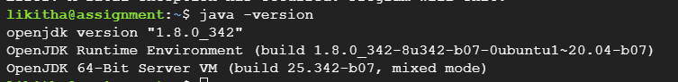

Installation of Hadoop:

likitha_shivananjegowda2@hadoop1:~$ wget <https://downloads.apache.org/hadoop/common/hadoop-3.2.3/hadoop-3.2.3.tar.gz>

likitha_shivananjegowda2@hadoop1:~$ sudo tar xvzf hadoop-3.2.3.tar.gz

likitha_shivananjegowda2@hadoop1:~$ sudo nano .bashrc

export HADOOP_HOME=/home/likitha/hadoop-3.2.3

export HADOOP_INSTALL=$HADOOP_HOME

export HADOOP_MAPRED_HOME=$HADOOP_HOME

export HADOOP_COMMON_HOME=$HADOOP_HOME

export HADOOP_HDFS_HOME=$HADOOP_HOME

export YARN_HOME=$HADOOP_HOME

export HADOOP_COMMON_LIB_NATIVE_DIR=$HADOOP_HOME/lib/native

export PATH=$PATH:$HADOOP_HOME/sbin:$HADOOP_HOME/bin

export HADOOP_OPTS="-Djava.library.path=$HADOOP_HOME/lib/native"

likitha_shivananjegowda2@hadoop1:~$ source ~/.bashrc

likitha_shivananjegowda2@hadoop1:~$ sudo nano $HADOOP_HOME/etc/hadoop/hadoop-env.sh

export JAVA_HOME=/usr/lib/jvm/java-8-openjdk-amd64

likitha_shivananjegowda2@hadoop1:~$ sudo nano $HADOOP_HOME/etc/hadoop/core-site.xml

<property>

<name>hadoop.tmp.dir</name>

<value>/home/likitha/tmpdata</value>

<description>A base for other temporary directories.</description>

</property>

<property>

<name>fs.default.name</name>

<value>hdfs://localhost:9000</value>

<description>The name of the default file system></description>

</property>

likitha_shivananjegowda2@hadoop1:~ $ sudo nano $HADOOP_HOME/etc/hadoop/hdfs-site.xml

<property>

<name>dfs.data.dir</name>

<value>/home/likitha/dfsdata/namenode</value>

</property>

<property>

<name>dfs.data.dir</name>

<value>/home/likitha/dfsdata/datanode</value>

</property>

<property>

<name>dfs.replication</name>

<value>1</value>

</property>

likitha_shivananjegowda2@hadoop1:~$ sudo nano $HADOOP_HOME/etc/hadoop/mapred-site.xml

<property>

<name>mapreduce.framework.name</name>

<value>yarn</value>

</property>

likitha_shivananjegowda2@hadoop`:~$ sudo nano $HOME_HOME/etc/hadoop/yarn-site.xml

<property>

<name>yarn.nodemanager.aux-services</name>

<value>mapreduce_shuffle</value>

</property>

<property>

<name>yarn.nodemanager.aux-services.mapreduce.shuffle.class</name>

<value>org.apache.hadoop.mapred.ShuffleHandler</value>

</property>

<property>

<name>yarn.resourcemanager.hostname</name>

<value>127.0.0.1</value>

</property>

<property>

<name>yarn.acl.enable</name>

<value>0</value>

</property>

<property>

<name>yarn.nodemanager.env-whitelist</name>

<value>JAVA_HOME,HADOOP_COMMON_HOME,HADOOP_HDFS_HOME,HADOOP_CONF_DIR,CLASSPATH_PERPEND_DISTCACHE,HADOOP_YARN_HOME,HADOOP_MAPRED_HOME</value>

</property>

likitha_shivananjegowda2@hadoop1:~$ hdfs name -format

likitha_shivananjegowda2@hadoop1:~$ ./start-dfs.sh

likitha_shivananjegowda2@hadoop1:~$ ./start-yarn.sh

likitha_shivananjegowda2@hadoop1:~$ jps

Installation of Pig:

likitha_shivananjegowda2@hadoop1:~$ wget <https://dlcdn.apache.org/pig/pig-0.16.0/pig-0.16.0.tar.gz>

likitha_shivananjegowda2@hadoop1:~$ tar xvzf pig-0.16.0.tar.gz

likitha_shivananjegowda2@hadoop1:~$ sudo mv /home/likitha_shivananjegowda2/pig-0.16.0 /home/likitha_shivananjegowda2/pig

likitha_shivananjegowda2@hadoop1:~$ sudo nano .bashrc

export PIG_HOME=/home/likitha/pig

export PATH=$PATH:$PIG_HOME/bin

export PIG_CLASSPATH=$PIG_HOME/conf:$HADOOP_INSTALL/etc/hadoop/

export PIG_CONF_DIR=$PIG_HOME/conf

export JAVA_HOME=/usr/lib/jvm/java-8-openjdk-amd64

export PIG_CLASSPATH=$PIG_CONF_DIR:$PATH

likitha_shivananjegowda2@hadoop1:~$ source .bashrc

likitha_shivananjegowda2@hadoop1:~$ pig

Installation of Hive:

likitha_shivananjegowda2@hadoop1:~$ wget <https://downloads.apache.org/hive/hive-3.1.2/apache-hive-3.1.2-bin.tar.gz>

likitha_shivananjegowda2@hadoop1:~$ tar xvzf apache-hive-3.1.2-bin.tar.gz

likitha_shivananjegowda2@hadoop1:~$ sudo mv apache-hive-3.1.2-bin hive

likitha_shivananjegowda2@hadoop1:~$ sudo nano ~/.bashrc

export HIVE_HOME=/usr/local/hive

export PATH=$PATH:$HIVE_HOME/bin

likitha_shivananjegowda2@hadoop1:~$ source ~/.bashrc

likitha_shivananjegowda2@hadoop1:~$ sudo nano $HIVE_HOME/bin/hive-config.sh

export HADOOP_HOME=/home/likitha/hadoop-3.2.1

likitha_shivananjegowda2@hadoop1:~$ hdfs dfs -mkdir /tmp

likitha_shivananjegowda2@hadoop1:~$ hdfs dfs -chmod g+w/tmp

likitha_shivananjegowda2@hadoop1:~$ hdfs dfs -mkdir -p /user/hive/warehouse

likitha_shivananjegowda2@hadoop1:~$ hdfs dfs -chmod g+w /user/hive/warehouse

likitha_shivananjegowda2@hadoop1:~$ rm $HIVE_HOME /lib/guava-19.0.jar

likitha_shivananjegowda2@hadoop1:~$cp $HADOOP_HOME/share/hadoop/hdfs/lib/guava-27.0-jre.jar $HIVE_HOME/lib/schematool -initSchema -dbType derby

likitha_shivananjegowda2@hadoop1:~$ cd $HIVE_HOME/conf

likitha_shivananjegowda2@hadoop1:~$ cp hive-default.xml.template hive-site.xml

likitha_shivananjegowda2@hadoop1:~$sudo nano hive-site.xml

likitha_shivananjegowda2@hadoop1:~$ hive

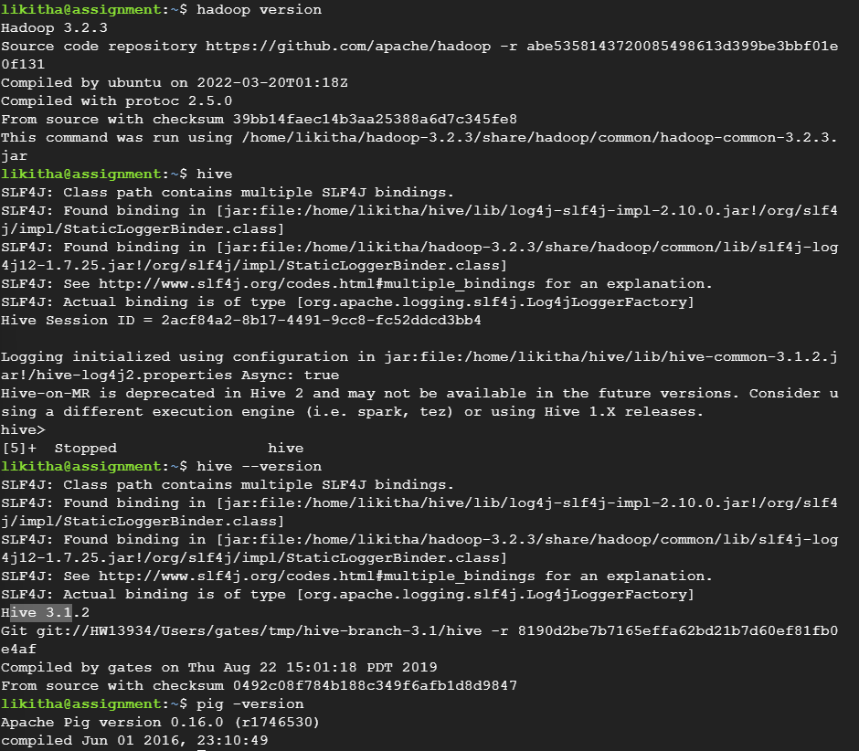

TASK 2:

Get dataset from Public repository provided link to respective repo:

Link to the dataset used :

<https://www.kaggle.com/datasets/naveedhn/amazon-product-review-spam-and-non-spam?select=Toys_and_Games>

In the dataset used which has amazon product reviews labeled as Spam or Ham. There are around million reviewers in this large corpus. The class labels are Spam and Ham, with a "0" indicating no spam and a "1" indicating spam reviews.

Since I have got json file so used python convert csv file:

import pandas as pd

import numpy

import json

df1= pd.read_json("C:/Users/likit/Downloads/Toys_and_Games/Toys_and_Games.json", lines=True, nrows=500)

cnt=0

for df in pd.read_json('C:/Users/likit/Downloads/Toys_and_Games/Toys_and_Games.json', lines=True, chunksize=1997140):

print(df.shape)

cnt=cnt+1

path=f"Toys_and_Games_{cnt}.csv"

df.to_csv(path)

df = pd.read_csv('C:/Users/likit/Toys_and_Games.csv')

Uploading the csv file based on class of the emails

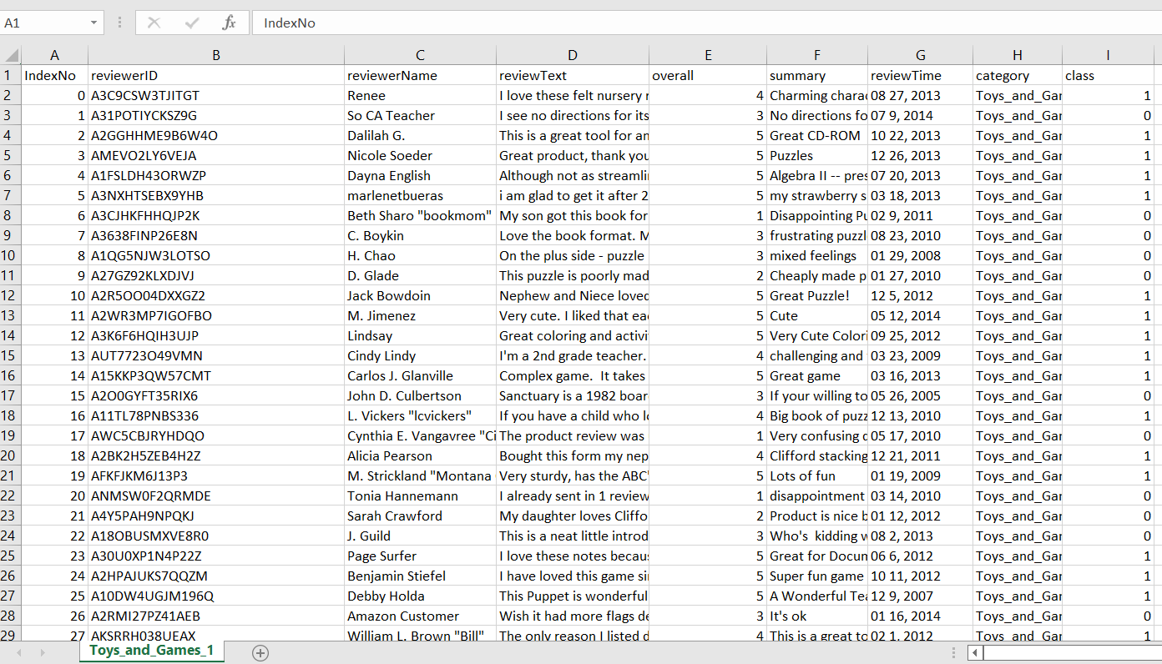

Using this csv file I have manually updated the data into the dataproc cluster

Task 3:

Data cleaning is the process of removing or correcting incorrect records from a table. The rules used to clean the data are determined by the business requirements.

In the dataset I have taken the date must be within a class to differenciate between ham and spam. I believe the Dataset may contain records with dates that are outside of the proper accuracy at some point, we can filter those records in a Relation in Pig and use that relation to implement Logic.To filter out records where columns have NULL values and the logic does not want those values to be NULL. You can update those records in a relation that have the string value NA by hard coding Field values and creating a separate relation for NULL values.

When I check the length of a specific field it was seen that there may be some junk values in String fields. While it was exceeding the threshold, it can be filtered by going through the records.

Everything depends on the data, so one must perform data validation to ensure that corrupt records can be cleaned by integrating various data validation checks into the Pig Script.

To clean and process the data I have used pig and hive queries

1st to upload files from local home directory to hadoop using commands

Likitha_shivananjegowda2@spamdetectionengine:~$ ls

Likitha_shivananjegowda2@spamdetectionengine:~$ hadoop fs -put Toys_and_Games_1.csv

Likitha_shivananjegowda2@spamdetectionengine:~$cat Toys_and_Games.csv

2nd used pig to clean data like replaced it with newlines where there were spaces

Likitha_shivananjegowda2@spamdetectionengine:~$ sed':a;N;$!ba;s/\n//g' Toys_and_Games > Toys_And_Games.csv

> pig – useHCatalog

> REGISTER /usr/lib/pig/piggybank.jar

> DEFINE CSVLoader org.apache.pig.piggybank.storage.CSVLoader();

In order to load data from Hadoop to Pig

Likitha_shivananjegowda2@spamdetectionengine:~$LOAD'/Toys_and_Games'USING org.apache.pig.piggybank.storage.CSVExcelStorage (',','YES_MULTILINE','NOCHANGE','SKIP_INPUT_HEADER') AS (IndexNo BIGINT,reviewerID String,reviewerName varchar(255),reviewText varchar(255),overall int,summary varchar(255),reviewTime varchar(255),category varchar(255),class String);

To remove newlines form the body column and dump clean data:

Likitha_shivananjegowda2@spamdetectionengine:~$ cleaneddata FOREACH stackdata GENERATE IndexNo, reviewerID, reviewerName, reviewText, overall, summary,class (REPLACE(body,'[\r\n]+',' ')) AS body

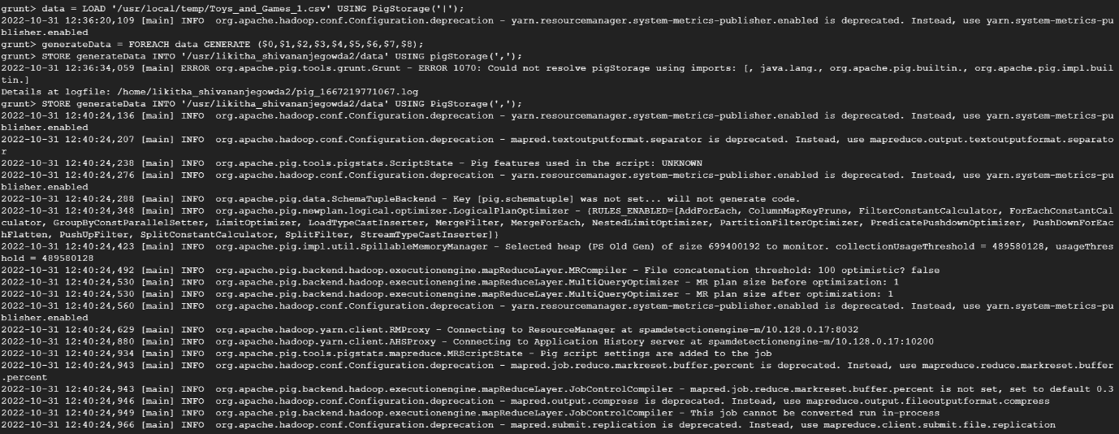

Step to load cleaned data from Pig to Hive we create database and table in Hive

hive> CREATE DATABASE spamdetection;

hive> USE spamdetection;

hive> CREATE TABLE spamdetection (IndexNo BIGINT,reviewerID String,reviewerName varchar(255),reviewText varchar(255),overall int,summary varchar(255),reviewTime varchar(255),category varchar(255),class String);

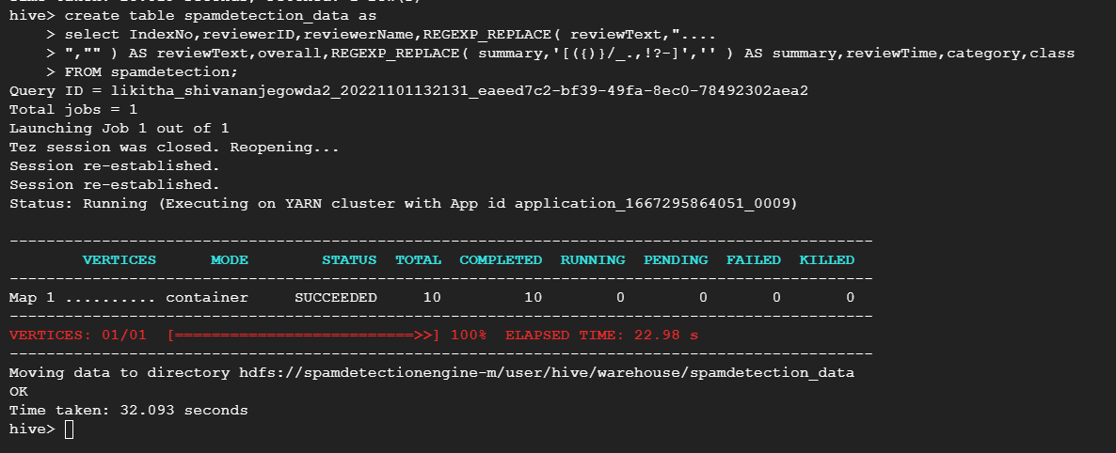

hive> describe spamdetection;

hive> select * from spamdetection;

//load for all table working

hive> LOAD DATA INPATH '/user/likitha_shivananjegowda2/mydir/Toys_and_Games.csv' INTO TABLE spamdetection; // LOADING THE FROM HDFS

hive> SELECT * FROM spamdetection LIMIT 10; // TO CHECK THE DATA ACCRUARCY

//creating new enriched table structure

hive> create table spamdetection_data as

hive> select IndexNo,reviewerID,reviewerName,REGEXP_REPLACE( reviewText,'[({)}/_.,!?-]',"" ) AS reviewText,overall,REGEXP_REPLACE( summary,'[({)}/_.,!?-]',"" ) AS summary,reviewTime,category,class

FROM spamdetection ;

//enriched loading data

Hive> insert overwrite table (spamdetection_data select IndexNo,reviewerID,reviewerName,REGEXP_REPLACE( reviewText,'[({)}/_.,!?-]',"" ) AS reviewText,overall,REGEXP_REPLACE( summary,'[({)}/_.,!?-]',"" ) AS summary,reviewTime,category,class ) FROM spamdetection;

//creating table for spam and ham

Hive> create table spamdetection_data_spam as

Hive> select * from spamdetection_data where class =true;

Hive>create table spamdetection_data_ham as

Hive> select * from spamdetection_data where class =false;

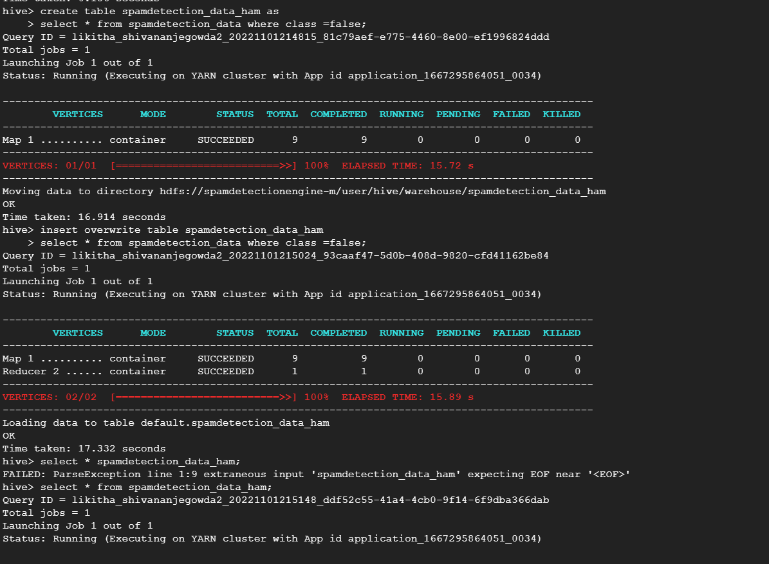

/inserting values to spam table

Hive> insert overwrite table spamdetection_data_spam

Hive> select * from spamdetection_data where class =true;

Hive> insert overwrite table spamdetection_data_ham

Hive> select * from spamdetection_data where class =false;

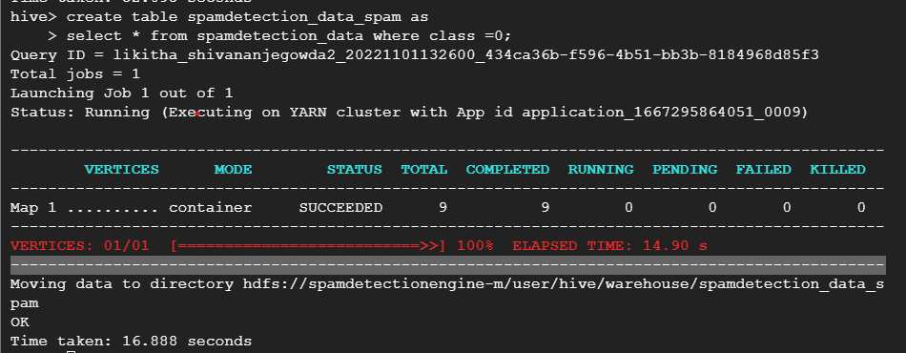

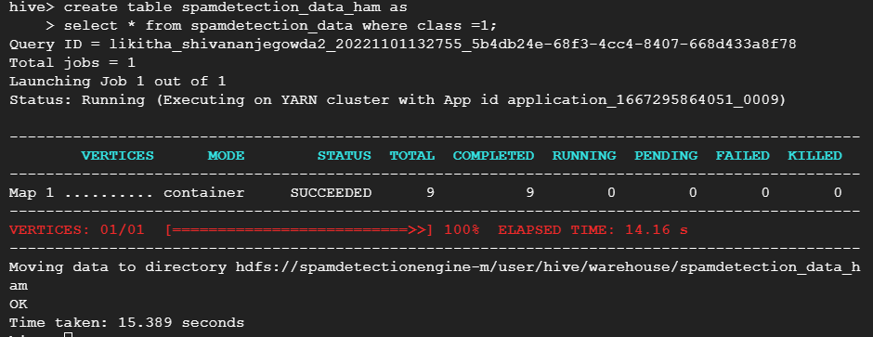

// query to list top 10 spam messages

Hive> select summary,count(*) from spamdetection_data_spam group by summary limit 10;

Tried the two queries to check if it works fine soo uploaded both the queries :

Hive> With topspam as(Select reviewerID,count(*)cnt from spamdetection_data_spam GROUP BY reviewerID)

Select reviewerID,cnt from topspam ORDER BY cnt DESC limit 10;

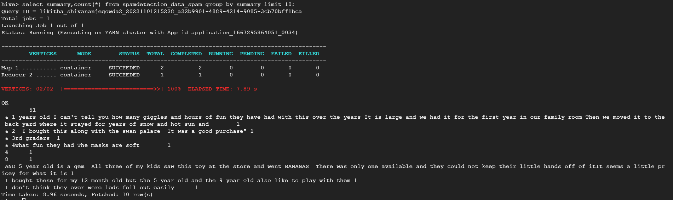

Task 5:

TF-IDF using MapReduce

tf-idf can be calculated with tfidf(t,d,D) = tf(t,d) * idf(t, D) where tf denotes the term frequency and idf the inverse frequency, while the tf can be calculated in different for me it was about classifying the dataset with spam or ham so I used Boolean expression. Also I find a normalized form where the data can be divided by making use of frequency found on counting the words.

In order to implement tf-idf using mapreduce I have divided the task into 2 as mapper and reducer in which I have a logic on implementing mapper and reducer programs in python and tried first implementing on local and I dint find any bugs in the code and delivered the same inside my Hadoop but im not excepting the output as the data is huge its failing displaying runtime error soo I had to end up with the same output I have given that screenshot respectively.

Commands I used to run the mapreduce program:

Likitha_shivananjegowda2@spamdetectionengine:~$ $HADOOP_HOME/bin/hadoop jar $HADOOP_HOME/hadoop-streaming.jar -input mapReduce1 -output mapReduce2 -file /home/likitha_shivananjegowda2/mapper1.py -mapper "python mapper1.py" -file /home/likitha_shivananjegowda2/reducer1.py -reducer "python reducer1.py"

Likitha_shivananjegowda2@spamdetectionengine:~$ $HADOOP_HOME/bin/hadoop jar $HADOOP_HOME/hadoop-streaming.jar -input mapReduce3 -output mapReduce4 -file /home/likitha_shivananjegowda2/mapper2.py -mapper "python mapper2.py" -file /home/likitha_shivananjegowda2/reducer2.py -reducer "python reducer2.py"

Likitha_shivananjegowda2@spamdetectionengine:~$ $HADOOP_HOME/bin/hadoop jar $HADOOP_HOME/hadoop-streaming.jar -input mapReduce5 -output mapReduce6 -file /home/likitha_shivananjegowda2/mapper3.py -mapper "python mapper3.py" -file /home/likitha_shivananjegowda2/reducer3.py -reducer "python reducer3.py"

